GLOBAL WRAP INC.
WE WRAP ANYTHING, ANYWHERE

globalwrap.com info@globalwrap.com 1-800-972-7120

Headquarters: 2205 Dobbs Rd, Suite B St Augustine, FL 32086

Philadelphia Office: 1108 Pine Street
Philadelphia, pa 19107

Global Wrap is a Woman Business Enterprise, Signatory to the Brotherhood of Carpenters, Member of the U.S. Green Building Council and the shrink wrap is recyclable.
GLOBAL

INC.
WRAP

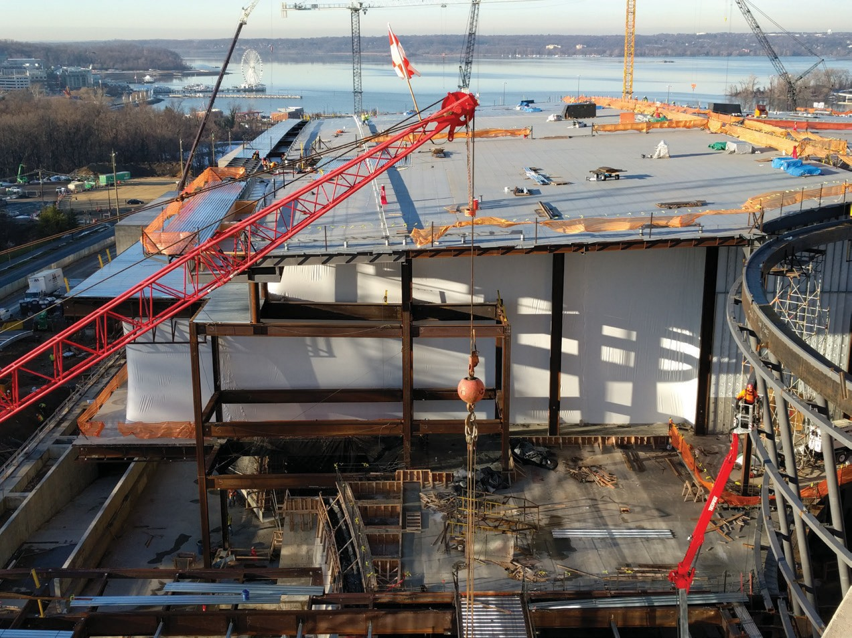“We Invented the process” since 1980

Exterior Protection
The Original Shrink Wrap Company Since 1980

Shrink Wrap Scaffolding
Global Wrap was the first to shrink wrap scaffolding with its drum-tight, fire retardant and seamless. Forget tarps blowing in the wind, Global Wrap the scaffolding.

Shrink Wrap Buildings
For keeping an ambient temperature for concrete pours, protect the completed interior work and to keep the trades working during inclement weather.

Dust Barrier
Walls
Flex-Walls©can be installed
any size to keep production going on one side and construction going on the other, heat control for winter concrete pours.

Shrink wrap Roof Decks
This process is used in disasters to seal a damaged roof, or in new construction when the new roof is delayed, it then can become the vapor barrier.

Temporary Curtain Walls
Global Wrap Flex-Walls© can be installed floor by floor and cut away in sections as the permanent
wall is installed.

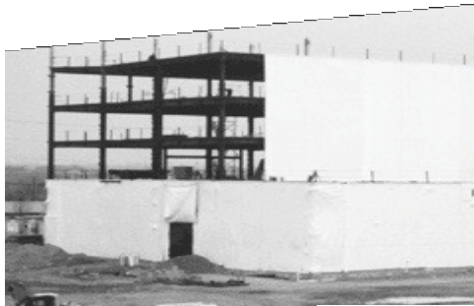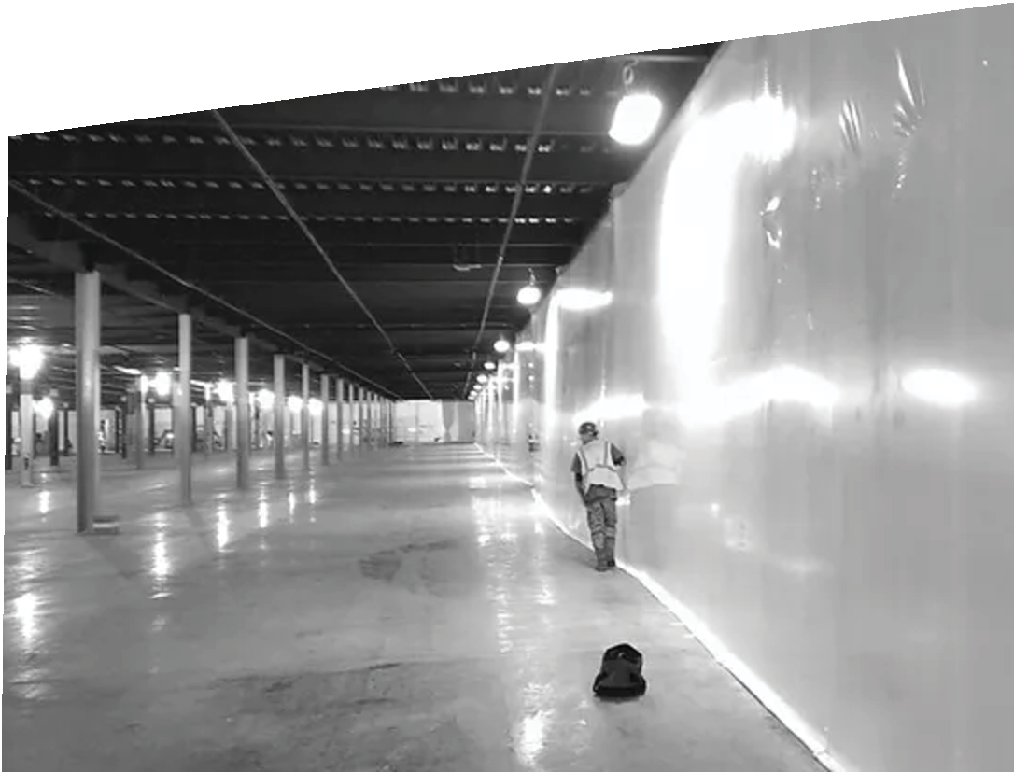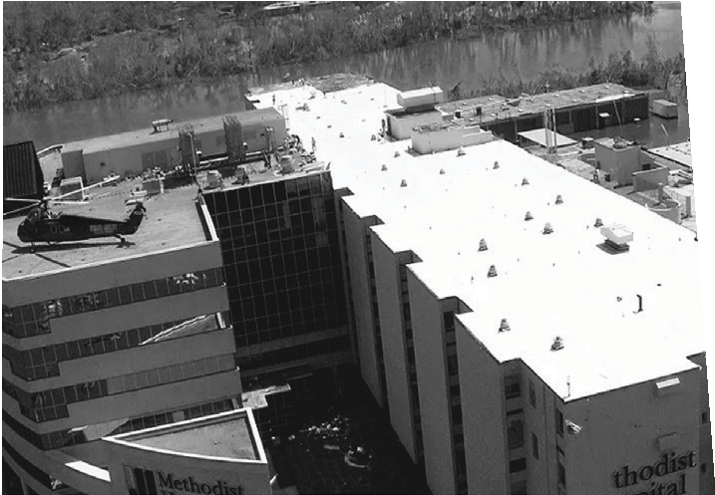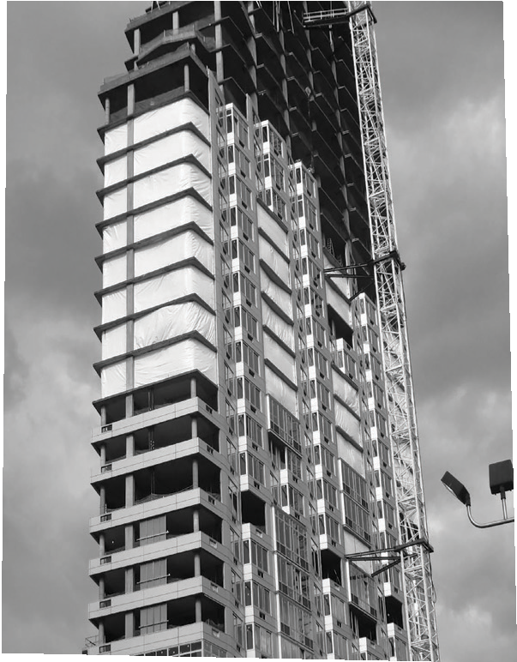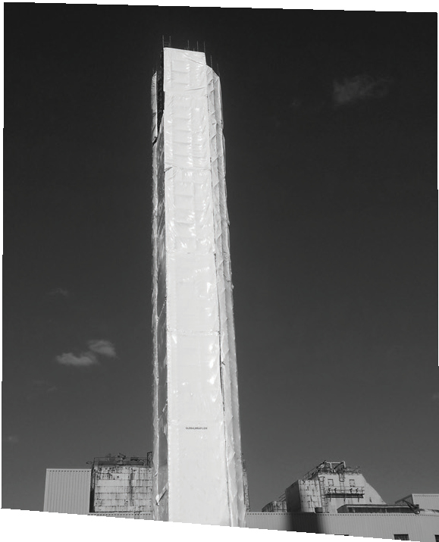

Add up the hidden costs of tarp failures: labor, materials and schedule delays, Global Wrap pays for itself.

